**Create Email Template In Odoo || Odoo Email Templates**

<https://youtu.be/zIDhiXQJiJo?si=YuChr-9s4PouC7Ub>

**Send Email From Odoo Using Email Template || Sending Emails From Odoo Using Code**

<https://youtu.be/fwZckHrRlp8?si=V4QaahQtQppBaQSV>

**Search in find in file**

model="mail.template"

**Note**: Use no_update=True in the data root tag. This ensures that if the project is given to a client and any changes are made to the email template via the UI, those changes remain intact even after upgrading the module.

**Step 1: Define the Email Template in XML**

In your Odoo module, go to the data directory (your_module/data/) and create an XML file, e.g., email_template.xml.

**Example: Creating an Email Template for Customer Welcome Email**

Create the file email_template.xml and add the following code:

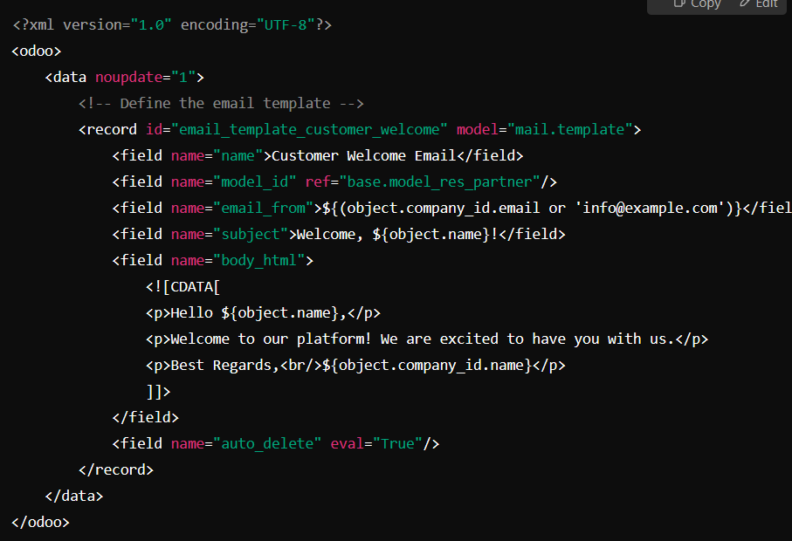

**Step 2: Add XML File to __manifest__.py**

Open the __manifest__.py file in your module and add the XML file inside the data list:

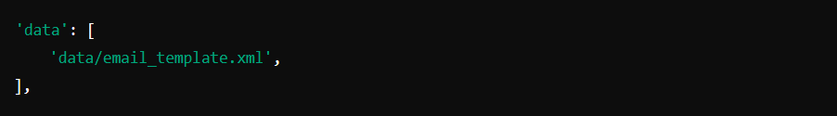

**Step 4: Using the Email Template in Python Code**

You can use this email template in your Python code to send emails. Example:

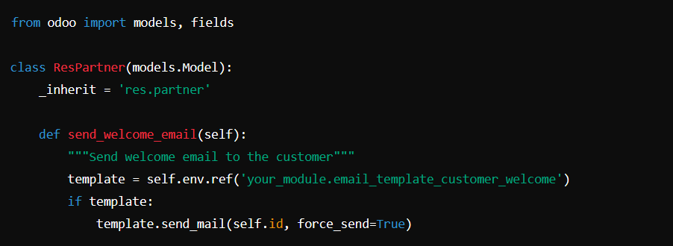

**Step 5: Call the Function (Optional)**

You can call send_welcome_email() in a button action or automatically trigger it using create() or write().